## Front End Engineering-II

Project Report

Semester-IV (Batch-2022)

**Title- Currency Converter**

GitHub Link: <https://github.com/Yajat047/fee_currency>

**Supervised By: Submitted By:**

Raveesh Samkaria Yajat Dureja

Roll Number - 2210990970

Group - 14

**Department of Computer Science and Engineering**

## Chitkara University Institute of Engineering & Technology,

## Chitkara University, Punjab

* **ABSTRACT:**

The Currency Converter project is a web-based application designed to enable users to convert currencies efficiently and conveniently.

The project provides a user-friendly interface where users can select the source currency, target currency, and enter the amount to be converted.

Utilizing HTML, CSS, Tailwind, and JavaScript, the Currency Converter includes essential features such as dropdown menus for currency selection, input fields for amount entry, and a conversion button to trigger the currency conversion process.

Tailwind min is used for CSS.

Additionally, it incorporates custom CSS to further tailor the visual presentation and enhance the user experience.

Overall, the Currency Converter project aims to provide a seamless and intuitive platform for currency conversion, catering to users seeking a quick and reliable method to convert currencies online.

Live Exchange Rate API has used for accurate conversion rates

By integrating this API into the project, users will be able to dynamically fetch the latest exchange rates relative to the US Dollar (USD) for various currencies.

1. **Introduction:** The Currency Converter project represents a modern and user-friendly web-based application designed to facilitate seamless currency conversions. Through the integration of real-time exchange rate data, users gain the ability to effortlessly convert between different currencies, providing a valuable tool for individuals and businesses requiring accurate and up-to-date currency conversion capabilities.
   1. **Background: -** In today's globalized economy, the ability to efficiently and accurately convert currencies is essential for international trade, travel, and financial transactions. Traditional methods of currency conversion often involve manual calculations or reliance on static exchange rate tables, leading to potential inaccuracies and inefficiencies. With this in mind, the Currency Converter project aims to address these challenges by offering a dynamic and reliable solution through the utilization of real-time exchange rate data.
   2. **Objectives:** The primary objective of the Currency Converter project is to develop a user-friendly and responsive web application that leverages live exchange rate data to enable seamless currency conversions. By integrating with real-time exchange rate APIs, the project seeks to provide users with an intuitive and efficient platform for accurate currency conversion, catering to a wide range of use cases, from individuals to multinational businesses.
   3. **Significance: -** The significance of the Currency Converter project lies in its ability to empower users with the tools necessary to perform accurate and timely currency conversions. The project's integration of live exchange rate data offers a distinct advantage over traditional static currency conversion methods, ensuring that users have access to the most current and reliable exchange rate information. In doing so, the project contributes to simplifying cross-border transactions, enhancing financial decision-making, and ultimately promoting greater convenience and accuracy in currency conversions.
2. **Problem Definition And Requirement:**
   1. **Problem Definition:** The Currency Converter project aims to address the challenges associated with traditional currency conversion methods by providing a seamless, reliable, and real-time solution. The primary objective is to develop a web-based application that leverages live exchange rate data to facilitate accurate and efficient currency conversions. The project seeks to overcome the limitations of manual conversion processes and static exchange rate tables by offering a user-friendly platform that caters to the diverse needs of individuals and businesses requiring up-to-date currency conversion capabilities.

**2.2 Software Requirement:**

**2.2.1. Web Development Tools:** HTML, CSS, JavaScript, Tailwind, API.

**2.2.2 Integration:** Utilization of real-time exchange rate API (e.g., 'https://api.exchangerate-api.com/v4/latest/USD') for fetching live currency exchange rates.

**2.2.3 Text Editor:** Any preferred text editor for code development and maintenance, for example : Visual Studio Code.

**2.2.4 Web Browse**r: Chrome, Firefox, Safari, or Edge for testing and deployment.

**2.3 Hardware Requirements:**

* + 1. **Desktops:** Compatible with standard desktop computers or workstations.
    2. **Laptops:** Supports various laptop models and configurations.
    3. **Internet Connection:** Required for fetching live exchange rate data through the API.
  1. **Data Sets**: The primary dataset utilized by the Currency Converter project is obtained from the real-time exchange rate API ('https://api.exchangerate-api.com/v4/latest/USD'). The dataset comprises up-to-date exchange rates for various currencies relative to the US Dollar (USD). It includes currency codes, corresponding exchange rates, and any additional metadata relevant to the conversion process. The dataset serves as the core source of live exchange rate information essential for accurately converting currencies within the application.

1. **Proposed Design/Methodology:**
   1. **Design Overview:-** The Currency Converter project is structured to provide a user-centric and intuitive interface for seamless currency conversion. The design includes a responsive layout built with HTML, styled using CSS and tailwind for a visually appealing and organized presentation. The project integrates JavaScript for dynamic functionality, enabling users to select source and target currencies, input the amount to be converted, and trigger the conversion process.
   2. **Methodology:** 
      1. **User Interface Design:** Utilize tailwind framework to create a visually appealing and responsive layout. Design user-friendly forms for currency selection and amount input using HTML and tailwind components.
      2. **Functionality Implementation:** Integrate JavaScript for handling user interactions, form validation, and triggering currency conversion requests. Implement API integration to fetch live exchange rate data for accurate conversions. Write custom JavaScript functions to calculate converted amounts based on the selected currencies and exchange rates.
2. **Results:** The Currency Converter project aims to provide users with a reliable, efficient, and user-friendly platform for performing accurate and up-to-date currency conversions.

**5. File Structure:-**

1. **index.html:** The heart of the Currency Converter App, index.html serves as the main entry point for the website. This file contains the HTML markup responsible for structuring the content and layout of the Currency Converter App. Elements such as currency inputs, conversion options, exchange rates display, and result summaries are defined within index.html, providing users with a seamless currency conversion experience.
2. **script.js:** The JavaScript functionality of the Currency Converter App is encapsulated within the script.js file. Here, essential functionalities such as real-time currency conversion, rate calculation, and result feedback are implemented. script.js ensures the interactivity and responsiveness of the Currency Converter App, enhancing the overall user experience.
3. **styles.css:** The visual design of the Currency Converter App is managed through the styles.css file. This file contains custom CSS styles that are applied to HTML elements defined in index.html. From layout and typography to colors and responsiveness, styles.css ensures consistency and coherence in the visual design of the Currency Converter App.
4. **assets folder:** This folder contains all assets used in the Currency Converter App, including images, icons, and any other multimedia elements. By organizing assets in a separate folder, the Currency Converter App maintains a clean and efficient file structure, making it easier to manage and update visual elements as needed.

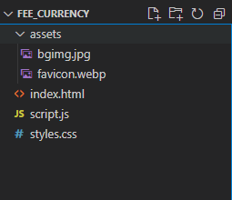

**User Interface Screenshots:**

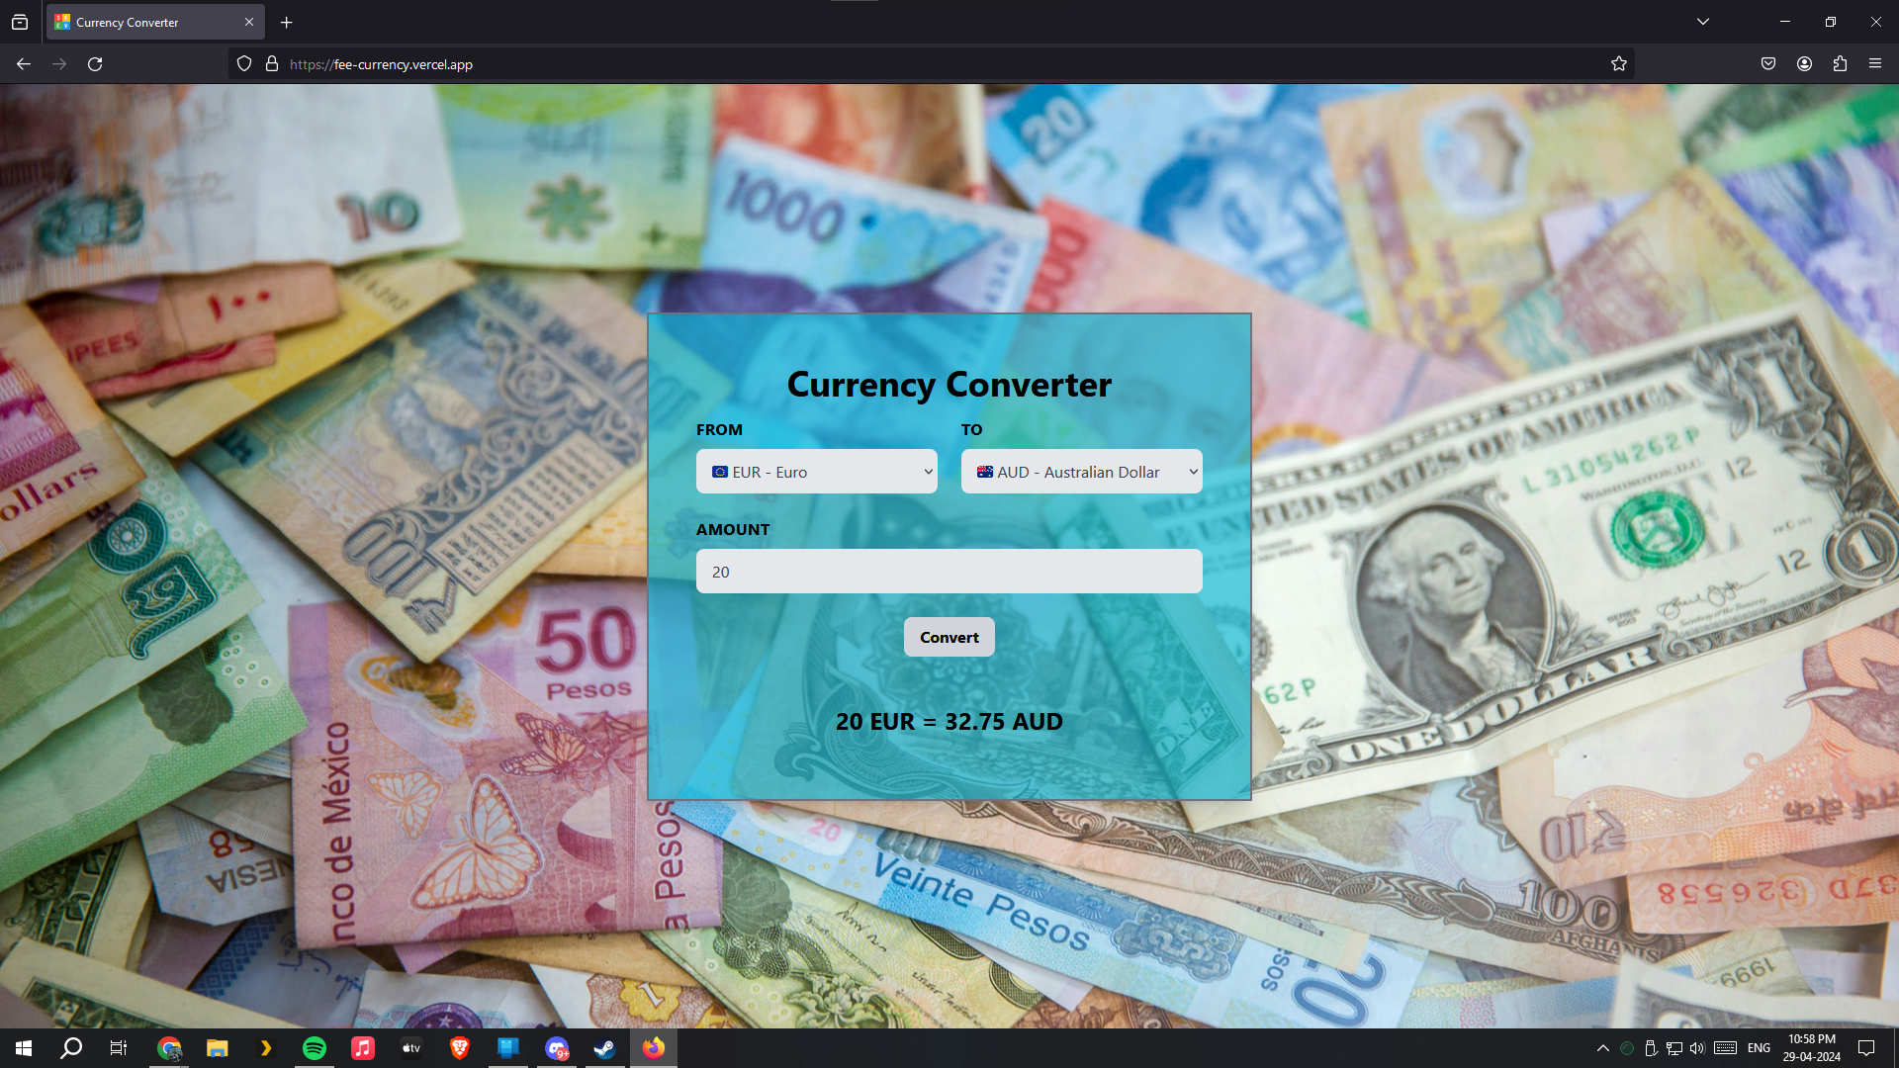

Mobile Optimized UI

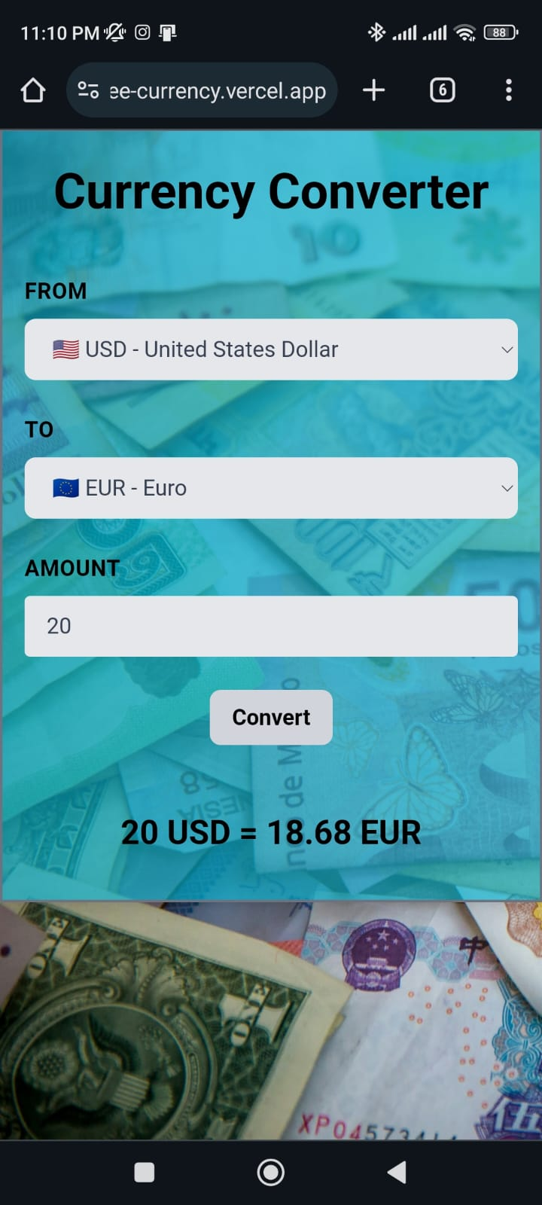

**HTML Code-**

**<!DOCTYPE html>**

**<html lang="en">**

**<head>**

**<meta charset="UTF-8">**

**<meta name="viewport" content="width=device-width, initial-scale=1.0">**

**<title>Currency Converter</title>**

**<script src="https://cdn.tailwindcss.com"></script>**

**<link rel="stylesheet" href="styles.css">**

**<script src="script.js"></script>**

**<link rel="icon" href="/assets/favicon.webp" type="image/x-icon">**

**</head>**

**<body class="bg-opacity-10 bg-cover" style="background-image: url('/assets/bgimg.jpg');">**

**<div class="md:flex justify-center items-center min-h-screen">**

**<div class="container border-2 border-gray-500 mx-auto p-4 pt-6 md:p-6 lg:p-12 flex flex-col items-center justify-center bg-cyan-500 bg-opacity-65 shadow-lg w-fit mt-0">**

**<h1 class="text-4xl font-bold text-center mb-4">Currency Converter</h1>**

**<br>**

**<form class="w-full max-w-lg">**

**<div class="flex flex-wrap -mx-3 mb-6">**

**<div class="w-full md:w-1/2 px-3 mb-6 md:mb-0">**

**<label class="block uppercase tracking-wide font-bold mb-2 rounded-lg" for="fromCurrency">**

**From**

**</label>**

**<select id="fromCurrency" class="select-option block w-full bg-gray-200 text-gray-700 py-3 px-4 pr-8 leading-tight focus:outline-none focus:bg-white rounded-lg">**

**</select>**

**</div>**

**<div class="w-full md:w-1/2 px-3">**

**<label class="block uppercase tracking-wide font-bold mb-2 rounded-lg" for="toCurrency">**

**To**

**</label>**

**<select id="toCurrency" class="select-option block w-full bg-gray-200 text-gray-700 py-3 px-4 pr-8 leading-tight focus:outline-none focus:bg-white rounded-lg">**

**</select>**

**</div>**

**</div>**

**<div class="flex flex-wrap -mx-3 mb-6">**

**<div class="w-full px-3">**

**<label class="block uppercase tracking-wide font-bold mb-2 rounded" for="amount">**

**Amount**

**</label>**

**<input type="float" id="amount" class=" rounded block w-full bg-gray-200 text-gray-700 py-3 px-4 pr-8 leading-tight focus:outline-none focus:bg-white rounded-lg" value="1">**

**</div>**

**</div>**

**<div class="flex justify-center rounded">**

**<button id="convertBtn" class="bg-gray-300 hover:bg-gray-400 text-black font-bold py-2 px-4 rounded-lg" type="button">Convert</button>**

**</div>**

**<br>**

**<br>**

**<div id="result" class="text-2xl font-bold mb-4 text-center"></div>**

**</form>**

**</div>**

**</div>**

**</body>**

**</html>**

**JavaScript Code-**

**function populateCurrencies() {**

**var currencyData = [**

**// const countries = [**

**{**

**code: 'USD',**

**name: 'United States Dollar',**

**flag: '🇺🇸'**

**},**

**{**

**code: 'EUR',**

**name: 'Euro',**

**flag: '🇪🇺'**

**},**

**{**

**code: 'GBP',**

**name: 'British Pound',**

**flag: '🇬🇧'**

**},**

**{**

**code: 'JPY',**

**name: 'Japanese Yen',**

**flag: '🇯🇵'**

**},**

**{**

**code: 'CNY',**

**name: 'Chinese Yuan',**

**flag: '🇨🇳'**

**},**

**{**

**code: 'AUD',**

**name: 'Australian Dollar',**

**flag: '🇦🇺'**

**},**

**{**

**code: 'CAD',**

**name: 'Canadian Dollar',**

**flag: '🇨🇦'**

**},**

**{**

**code: 'CHF',**

**name: 'Swiss Franc',**

**flag: '🇨🇭'**

**},**

**{**

**code: 'HKD',**

**name: 'Hong Kong Dollar',**

**flag: '🇭🇰'**

**},**

**{**

**code: 'NZD',**

**name: 'New Zealand Dollar',**

**flag: '🇳🇿'**

**},**

**{**

**code: 'SEK',**

**name: 'Swedish Krona',**

**flag: '🇸🇪'**

**},**

**{**

**code: 'KRW',**

**name: 'South Korean Won',**

**flag: '🇰🇷'**

**},**

**{**

**code: 'SGD',**

**name: 'Singapore Dollar',**

**flag: '🇸🇬'**

**},**

**{**

**code: 'NOK',**

**name: 'Norwegian Krone',**

**flag: '🇳🇴'**

**},**

**{**

**code: 'MXN',**

**name: 'Mexican Peso',**

**flag: '🇲🇽'**

**},**

**{**

**code: 'INR',**

**name: 'Indian Rupee',**

**flag: '🇮🇳'**

**},**

**{**

**code: 'RUB',**

**name: 'Russian Ruble',**

**flag: '🇷🇺'**

**},**

**{**

**code: 'ZAR',**

**name: 'South African Rand',**

**flag: '🇿🇦'**

**},**

**{**

**code: 'BRL',**

**name: 'Brazilian Real',**

**flag: '🇧🇷'**

**},**

**{**

**code: 'TRY',**

**name: 'Turkish Lira',**

**flag: '🇹🇷'**

**},**

**{**

**code: 'TWD',**

**name: 'New Taiwan Dollar',**

**flag: '🇹🇼'**

**},**

**{**

**code: 'DKK',**

**name: 'Danish Krone',**

**flag: '🇩🇰'**

**},**

**{**

**code: 'THB',**

**name: 'Thai Baht',**

**flag: '🇹🇭'**

**},**

**{**

**code: 'IDR',**

**name: 'Indonesian Rupiah',**

**flag: '🇮🇩'**

**},**

**{**

**code: 'MYR',**

**name: 'Malaysian Ringgit',**

**flag: '🇲🇾'**

**},**

**{**

**code: 'PHP',**

**name: 'Philippine Peso',**

**flag: '🇵🇭'**

**},**

**{**

**code: 'CZK',**

**name: 'Czech Koruna',**

**flag: '🇨🇿'**

**},**

**{**

**code: 'PLN',**

**name: 'Polish Złoty',**

**flag: '🇵🇱'**

**},**

**{**

**code: 'HUF',**

**name: 'Hungarian Forint',**

**flag: '🇭🇺'**

**},**

**{**

**code: 'ILS',**

**name: 'Israeli New Shekel',**

**flag: '🇮🇱'**

**},**

**{**

**code: 'AED',**

**name: 'United Arab Emirates Dirham',**

**flag: '🇦🇪'**

**},**

**{**

**code: 'COP',**

**name: 'Colombian Peso',**

**flag: '🇨🇴'**

**},**

**{**

**code: 'SAR',**

**name: 'Saudi Riyal',**

**flag: '🇸🇦'**

**},**

**{**

**code: 'EGP',**

**name: 'Egyptian Pound',**

**flag: '🇪🇬'**

**},**

**{**

**code: 'ARS',**

**name: 'Argentine Peso',**

**flag: '🇦🇷'**

**},**

**{**

**code: 'CLP',**

**name: 'Chilean Peso',**

**flag: '🇨🇱'**

**},**

**{**

**code: 'PKR',**

**name: 'Pakistani Rupee',**

**flag: '🇵🇰'**

**},**

**{**

**code: 'VND',**

**name: 'Vietnamese Đồng',**

**flag: '🇻🇳'**

**},**

**{**

**code: 'UAH',**

**name: 'Ukrainian Hryvnia',**

**flag: '🇺🇦'**

**},**

**{**

**code: 'IQD',**

**name: 'Iraqi Dinar',**

**flag: '🇮🇶'**

**},**

**{**

**code: 'NGN',**

**name: 'Nigerian Naira',**

**flag: '🇳🇬'**

**},**

**{**

**code: 'RON',**

**name: 'Romanian Leu',**

**flag: '🇷🇴'**

**},**

**{**

**code: 'KES',**

**name: 'Kenyan Shilling',**

**flag: '🇰🇪'**

**},**

**{**

**code: 'DZD',**

**name: 'Algerian Dinar',**

**flag: '🇩🇿'**

**},**

**{**

**code: 'UGX',**

**name: 'Ugandan Shilling',**

**flag: '🇺🇬'**

**},**

**{**

**code: 'BDT',**

**name: 'Bangladeshi Taka',**

**flag: '🇧🇩'**

**},**

**{**

**code: 'MAD',**

**name: 'Moroccan Dirham',**

**flag: '🇲🇦'**

**},**

**{**

**code: 'VND',**

**name: 'Vietnamese Dong',**

**flag: '🇻🇳'**

**},**

**{**

**code: 'LBP',**

**name: 'Lebanese Pound',**

**flag: '🇱🇧'**

**},**

**{**

**code: 'GHS',**

**name: 'Ghanaian Cedi',**

**flag: '🇬🇭'**

**},**

**{**

**code: 'TZS',**

**name: 'Tanzanian Shilling',**

**flag: '🇹🇿'**

**},**

**{**

**code: 'UGX',**

**name: 'Ugandan Shilling',**

**flag: '🇺🇬'**

**},**

**{**

**code: 'MMK',**

**name: 'Burmese Kyat',**

**flag: '🇲🇲'**

**},**

**{**

**code: 'AFN',**

**name: 'Afghan Afghani',**

**flag: '🇦🇫'**

**},**

**{**

**code: 'XAF',**

**name: 'Central African CFA Franc',**

**flag: '🇨🇫'**

**},**

**{**

**code: 'XOF',**

**name: 'West African CFA Franc',**

**flag: '🇹🇩'**

**},**

**{**

**code: 'MZN',**

**name: 'Mozambican Metical',**

**flag: '🇲🇿'**

**},**

**{**

**code: 'XPF',**

**name: 'CFP Franc',**

**flag: '🇵🇫'**

**},**

**{**

**code: 'TND',**

**name: 'Tunisian Dinar',**

**flag: '🇹🇳'**

**},**

**{**

**code: 'CRC',**

**name: 'Costa Rican Colón',**

**flag: '🇨🇷'**

**},**

**{**

**code: 'PEN',**

**name: 'Peruvian Sol',**

**flag: '🇵🇪'**

**},**

**{**

**code: 'UYU',**

**name: 'Uruguayan Peso',**

**flag: '🇺🇾'**

**},**

**{**

**code: 'DOP',**

**name: 'Dominican Peso',**

**flag: '🇩🇴'**

**},**

**{**

**code: 'HRK',**

**name: 'Croatian Kuna',**

**flag: '🇭🇷'**

**},**

**{**

**code: 'GTQ',**

**name: 'Guatemalan Quetzal',**

**flag: '🇬🇹'**

**},**

**{**

**code: 'HNL',**

**name: 'Honduran Lempira',**

**flag: '🇭🇳'**

**},**

**{**

**code: 'ISK',**

**name: 'Icelandic Króna',**

**flag: '🇮🇸'**

**},**

**{**

**code: 'JMD',**

**name: 'Jamaican Dollar',**

**flag: '🇯🇲'**

**},**

**{**

**code: 'LKR',**

**name: 'Sri Lankan Rupee',**

**flag: '🇱🇰'**

**},**

**{**

**code: 'MDL',**

**name: 'Moldovan Leu',**

**flag: '🇲🇩'**

**},**

**{**

**code: 'MOP',**

**name: 'Macanese Pataca',**

**flag: '🇲🇴'**

**},**

**{**

**code: 'MKD',**

**name: 'Macedonian Denar',**

**flag: '🇲🇰'**

**},**

**{**

**code: 'NPR',**

**name: 'Nepalese Rupee',**

**flag: '🇳🇵'**

**},**

**{**

**code: 'PAB',**

**name: 'Panamanian Balboa',**

**flag: '🇵🇦'**

**},**

**{**

**code: 'BHD',**

**name: 'Bahraini Dinar',**

**flag: '🇧🇭'**

**},**

**{**

**code: 'BYN',**

**name: 'Belarusian Ruble',**

**flag: '🇧🇾'**

**},**

**{**

**code: 'BOB',**

**name: 'Bolivian Boliviano',**

**flag: '🇧🇴'**

**},**

**{**

**code: 'BND',**

**name: 'Brunei Dollar',**

**flag: '🇧🇳'**

**},**

**{**

**code: 'BWP',**

**name: 'Botswana Pula',**

**flag: '🇧🇼'**

**},**

**{**

**code: 'BGN',**

**name: 'Bulgarian Lev',**

**flag: '🇧🇬'**

**},**

**{**

**code: 'CDF',**

**name: 'Congolese Franc',**

**flag: '🇨🇩'**

**},**

**{**

**code: 'ANG',**

**name: 'Netherlands Antillean Guilder',**

**flag: '🇦🇳'**

**},**

**{**

**code: 'CUP',**

**name: 'Cuban Peso',**

**flag: '🇨🇺'**

**},**

**{**

**code: 'DJF',**

**name: 'Djiboutian Franc',**

**flag: '🇩🇯'**

**},**

**{**

**code: 'ERN',**

**name: 'Eritrean Nakfa',**

**flag: '🇪🇷'**

**},**

**{**

**code: 'ETB',**

**name: 'Ethiopian Birr',**

**flag: '🇪🇹'**

**},**

**{**

**code: 'FJD',**

**name: 'Fijian Dollar',**

**flag: '🇫🇯'**

**},**

**{**

**code: 'GEL',**

**name: 'Georgian Lari',**

**flag: '🇬🇪'**

**},**

**{**

**code: 'GYD',**

**name: 'Guyanaese Dollar',**

**flag: '🇬🇾'**

**},**

**{**

**code: 'HTG',**

**name: 'Haitian Gourde',**

**flag: '🇭🇹'**

**},**

**{**

**code: 'KHR',**

**name: 'Cambodian Riel',**

**flag: '🇰🇭'**

**},**

**{**

**code: 'KWD',**

**name: 'Kuwaiti Dinar',**

**flag: '🇰🇼'**

**},**

**{**

**code: 'KGS',**

**name: 'Kyrgyzstani Som',**

**flag: '🇰🇬'**

**},**

**{**

**code: 'LAK',**

**name: 'Lao Kip',**

**flag: '🇱🇦'**

**},**

**{**

**code: 'LSL',**

**name: 'Lesotho Loti',**

**flag: '🇱🇸'**

**},**

**{**

**code: 'LRD',**

**name: 'Liberian Dollar',**

**flag: '🇱🇷'**

**},**

**{**

**code: 'LYD',**

**name: 'Libyan Dinar',**

**flag: '🇱🇾'**

**},**

**{**

**code: 'MGA',**

**name: 'Malagasy Ariary',**

**flag: '🇲🇬'**

**},**

**{**

**code: 'MWK',**

**name: 'Malawian Kwacha',**

**flag: '🇲🇼'**

**},**

**{**

**code: 'MVR',**

**name: 'Maldivian Rufiyaa',**

**flag: '🇲🇻'**

**},**

**{**

**code: 'MRO',**

**name: 'Mauritanian Ouguiya',**

**flag: '🇲🇷'**

**},**

**{**

**code: 'MUR',**

**name: 'Mauritian Rupee',**

**flag: '🇲🇺'**

**},**

**{**

**code: 'MDL',**

**name: 'Moldovan Leu',**

**flag: '🇲🇩'**

**},**

**{**

**code: 'MNT',**

**name: 'Mongolian Tugrik',**

**flag: '🇲🇳'**

**},**

**{**

**code: 'MAD',**

**name: 'Moroccan Dirham',**

**flag: '🇲🇦'**

**},**

**{**

**code: 'MZN',**

**name: 'Mozambican Metical',**

**flag: '🇲🇿'**

**},**

**{**

**code: 'NAD',**

**name: 'Namibian Dollar',**

**flag: '🇳🇦'**

**},**

**{**

**code: 'NIO',**

**name: 'Nicaraguan Córdoba',**

**flag: '🇳🇮'**

**},**

**{**

**code: 'OMR',**

**name: 'Omani Rial',**

**flag: '🇴🇲'**

**},**

**{**

**code: 'PGK',**

**name: 'Papua New Guinean Kina',**

**flag: '🇵🇬'**

**},**

**{**

**code: 'PYG',**

**name: 'Paraguayan Guarani',**

**flag: '🇵🇾'**

**},**

**{**

**code: 'QAR',**

**name: 'Qatari Riyal',**

**flag: '🇶🇦'**

**},**

**{**

**code: 'RWF',**

**name: 'Rwandan Franc',**

**flag: '🇷🇼'**

**},**

**{**

**code: 'WST',**

**name: 'Samoan Tala',**

**flag: '🇼🇸'**

**},**

**{**

**code: 'STN',**

**name: 'São Tomé and Príncipe Dobra',**

**flag: '🇸🇹'**

**},**

**{**

**code: 'RSD',**

**name: 'Serbian Dinar',**

**flag: '🇷🇸'**

**},**

**{**

**code: 'SCR',**

**name: 'Seychellois Rupee',**

**flag: '🇸🇨'**

**},**

**{**

**code: 'SLL',**

**name: 'Sierra Leonean Leone',**

**flag: '🇸🇱'**

**},**

**{**

**code: 'SBD',**

**name: 'Solomon Islands Dollar',**

**flag: '🇸🇧'**

**},**

**{**

**code: 'SOS',**

**name: 'Somali Shilling',**

**flag: '🇸🇴'**

**},**

**{**

**code: 'SSP',**

**name: 'South Sudanese Pound',**

**flag: '🇸🇸'**

**},**

**{**

**code: 'SDG',**

**name: 'Sudanese Pound',**

**flag: '🇸🇩'**

**},**

**{**

**code: 'SRD',**

**name: 'Surinamese Dollar',**

**flag: '🇸🇷'**

**},**

**{**

**code: 'TJS',**

**name: 'Tajikistani Somoni',**

**flag: '🇹🇯'**

**},**

**{**

**code: 'TMT',**

**name: 'Turkmenistani Manat',**

**flag: '🇹🇲'**

**},**

**{**

**code: 'TOP',**

**name: 'Tongan Paʻanga',**

**flag: '🇹🇴'**

**},**

**{**

**code: 'TTD',**

**name: 'Trinidad and Tobago Dollar',**

**flag: '🇹🇹'**

**},**

**{**

**code: 'TVD',**

**name: 'Tuvaluan Dollar',**

**flag: '🇹🇻'**

**},**

**{**

**code: 'UGX',**

**name: 'Ugandan Shilling',**

**flag: '🇺🇬'**

**},**

**{**

**code: 'UYU',**

**name: 'Uruguayan Peso',**

**flag: '🇺🇾'**

**},**

**{**

**code: 'UZS',**

**name: 'Uzbekistani Som',**

**flag: '🇺🇿'**

**},**

**{**

**code: 'VUV',**

**name: 'Vanuatu Vatu',**

**flag: '🇻🇺'**

**},**

**{**

**code: 'YER',**

**name: 'Yemeni Rial',**

**flag: '🇾🇪'**

**},**

**{**

**code: 'ZMW',**

**name: 'Zambian Kwacha',**

**flag: '🇿🇲'**

**},**

**{**

**code: 'ZWL',**

**name: 'Zimbabwean Dollar',**

**flag: '🇿🇼'**

**}**

**];**

**const amountInput = document.getElementById('amount');**

**amountInput.addEventListener('input', function () {**

**// Limit decimal places to two**

**const parts = this.value.split('.');**

**if (parts.length > 1) {**

**parts[1] = parts[1].slice(0, 2);**

**this.value = parts.join('.');**

**}**

**});**

**document.addEventListener('keydown', function (e) {**

**if (e.key === 'Enter' && document.activeElement === amountInput) {**

**e.preventDefault()**

**document.getElementById('convertBtn').click();**

**}**

**});**

**var fromCurrencyDropdown = document.getElementById('fromCurrency');**

**var toCurrencyDropdown = document.getElementById('toCurrency');**

**currencyData.forEach(currency => {**

**var option1 = document.createElement('option');**

**option1.value = currency.code;**

**option1.innerText = `${currency.flag} ${currency.code} - ${currency.name}`;**

**fromCurrencyDropdown.appendChild(option1);**

**var option2 = document.createElement('option');**

**option2.value = currency.code;**

**option2.innerText = `${currency.flag} ${currency.code} - ${currency.name}`;**

**toCurrencyDropdown.appendChild(option2);**

**});**

**}**

**document.addEventListener('DOMContentLoaded', function () {**

**populateCurrencies();**

**document.getElementById('convertBtn').addEventListener('click', function () {**

**var fromCurrency = document.getElementById('fromCurrency').value;**

**var toCurrency = document.getElementById('toCurrency').value;**

**var amount = document.getElementById('amount').value;**

**fetch(`https://open.er-api.com/v6/latest/${fromCurrency}`)**

**.then(response => response.json())**

**.then(data => {**

**var rate = data.rates[toCurrency];**

**var convertedAmount = amount * rate;**

**document.getElementById('result').innerText = `${amount} ${fromCurrency} = ${convertedAmount.toFixed(2)} ${toCurrency}`;**

**})**

**.catch(error => {**

**console.log(error);**

**document.getElementById('result').innerText = 'Error fetching data. Please try again later.';**

**});**

**});**

**});**